SAD PROJECT OUTLINE

UNIVERSITY OF RIZAL SYSTEM
Province of Rizal
College of Science

A SYSTEM PROPOSAL
In Partial Fulfillment of the Requirements in Systems Analysis and Design

Members:

BS IN COMPUTER SCIENCE

MARIA CECILIA P. SAN JOSE
Professor

November 2026
TABLE OF CONTENTS

- Historical Background of the Organization - Domm
- Brief Description of the System - Prince
- THE EXISTING SYSTEM
  - Description of the Existing System - Zairra
  - Data Flow Diagram
    - Context Level DFD - Domm
    - Level 1 DFD - Andrei
    - Level 2 DFD - Andrei
  - Existing Data Dictionary - Karl
- PROBLEM DEFINITION - Zairra
- OBJECTIVES - Rowena
  - General Objective
  - Specific Objectives
- THE PROPOSED SYSTEM
  - Description of Proposed System - Rowena
  - Conceptual Model for the Proposed System- Karl
  - Data Flow Diagram
    - Context Level DFD - Domm
    - Level 1 -
    - Level 2 -
  - Data Dictionary - Prince
  - Proposed Hardware and Software Specification -Coltrane
    - Hardware
    - Software
    - Costs

      - Recursive Costs
      - Non-Recursive Costs

APENDICES
A. SAMPLE USER INTERFACE OF THE PROPOSED SYSTEM
B. GANTT CHART OF ACTIVITIES - Andrei
C. OTHER RELEVANT DOCUMENTS - Coltrane
C. CURRICULUM VITAE

NOTES:
- Your manuscript should be in portable document format (pdf)

(for midterm submission of Chapter 1-3 only)
- Font is arial, size 12,
Paragraphs text alignment – justify Line spacing -double
Pagination – page no. is at the top right side of the header Paper Size: short bond paper
- Each group will submit 1 hard copy manuscript 2-3 days before the oral defense. also, turn-in a softcopy of your manuscript in Google Class (chapter 1-6)
- Attire during defense:
  - Business attire (if final defense is f2f)
  - School uniform (if online)
- Final oral defense schedule will be announced via google classroom 4-5 days before the oral defense.
Interview Questions:

INTERVIEW QUESTIONS
System Analysis of the Management and Reservation Process at Villa Corazon Events Place
Good morning , Sir and Ma'am. First of all, thank you po for allowing us to conduct this interview.
To start po, introduce ko lang po sarili namin, We are students taking up Bachelor of Science in Computer Science at the University of Rizal System – Morong Campus, currently enrolled in Systems Analysis and Design Course.

As part of our academic requirements, we are conducting a study of Villa Corazon Events Place's existing management and reservation process. The purpose of this interview is to understand yung background ng establishment, kung paano po prinoprocess at hinahandle ang reservations and payments, ang challenges na inyong naeencounter, and the features na possible proposed online management and reservation system.
The information gathered po will be used solely for academic purposes and will be handled confidentially. We will not assume any procedures or requirements without your confirmation.
If okay lang po lahat to sainyo, pwede na po ba tayo magstart ng interview?
just to inform nadin po na irerecord namin ang gmeet na ito for documentation

0. Historical Background of the Organization pwede po naming malaman

0.1 When was Villa Corazon Events Place established, where, and who founded it?
What inspired you to establish the business?
0.2. Where was it established?
0.3 What was the main reason behind establishing Villa Corazon?
0.4.What services does it initially offer sa villa corazon?
0.5 since its establishment, What are some major milestones na naachieve Villa Corazon?
Possible follow-up: Have there been significant changes in your services, facilities, customer base, or business operations?

1. User Reservation Process

1.1.How do you store client information?

1.2.What amenities or services do you have contact with? (Example: Lights and sounds, Catering Service, Hosting Service) connections na pwede pong mainquire ng mga clients

1.3. What is the process on how customers book their reservations? can you break down the stepby step process on how customers book their reservation From the initial inquiry to the filling up forms to the payment

2. Admin Responsibilities / Management

2.1. How are cancellations, rescheduling, and changes to a reservation handled? Paano ninyo hinahandle

2.2. How does the admin currently manage and monitor reservations and schedules? kabuuan

2.3. What information, dashboard, or reports would the admin need from the system? Everyday duties

3. Payment and Packages

3.1 What event packages and services do you offer, and what is included in each package?
- How do customers usually inquire about reservations?
- Who handles the inquiries?
- What steps are required before a booking is confirmed?

3.2 Can customers customize packages or add additio
nal services? Or fixed
3.3 What are the payment terms, ginagamitan po ninyo deposits, installments, and deadlines?
- What are your policies for deposits, installments, due dates, and remaining balances?
- How are payments recorded and verified?
- How do you handle refunds or payment adjustments when bookings are cancelled or changed?

3.4 sa tingin nyo po, how should the system track payments, remaining balances, cancellations, and refunds?
Possible follow-up: How are these changes recorded, and how are customers informed?

4. Layout / Design / Marketing

4.1.What theme, colors, logo, and overall design should the system follow? Vision mission
- Do you have an official logo, preferred colors, or existing branding?
- Which venue photos, facilities, and package details should be displayed?
- What contact information and business policies should appear on the website?

4.2. What venue photos, layouts, facilities, or other assets should be displayed? Market ang villa corazon

4.3 What information should customers see when viewing the venue and event packages?

4.4. What should customers see first when they open the system? First impression ng customers sa villa corazon

5. Additional System Requirements
Goal: Identify important features not covered by the previous sections.

5.1. What problems with the current reservation or management process should the new system solve? Solutions
Possible follow-ups:
- Is it difficult to check availability or retrieve previous records?
- Have you experienced scheduling conflicts, incomplete records, or communication problems?
- Which tasks take the most time or require the most manual work?

5.2. may katanungan kayo saamin? Or hindi namin naiclarify ng maayos

I. Historical Background of the Organization
1. When was Villa Corazon Events Place established, who founded it, and what was the purpose of its establishment?
2. What are the major developments or milestones of Villa Corazon Events Place since its establishment?

II. Existing Reservation and Management Process
3. Can you describe the current reservation process, from the customer's initial inquiry to the confirmation of the booking?
4. How are client information, reservation records, venue schedules, and event details currently recorded, stored, and updated?
5. How do you check venue availability and prevent scheduling conflicts or double-bookings?
6. How are reservation cancellations, rescheduling requests, and changes to booking details handled?

III. Packages and Payment Management
7. What event packages and additional services do you offer, and what are their inclusions, prices, and customization options?
8. What are your payment policies, including down payments, installment arrangements, payment deadlines, remaining balances, cancellations, and refunds?

IV. Problems and System Requirements
9. What difficulties or problems do you encounter in the current reservation and management process?
10. What features would you like the proposed system to have to address these problems and improve your operations?
11. What information, reports, or notifications would be most useful to management and customers?

V. Website Content and Design
12. What information, photographs, branding elements, and contact details should appear on the website, and what visual style would best represent Villa Corazon Events Place?

Thank you for your time and cooperation. Your responses will be used solely for academic purposes in analyzing the existing system and developing a proposal for an improved management and reservation system.

INTERVIEW TRANSCRIPT PER QUESTION
0. Historical Background of the Organization pwede po naming malaman

0.1 When was Villa Corazon Events Place established, where, and who founded it?
What inspired you to establish the business?
0.2. Where was it established?
0.3 What was the main reason behind establishing Villa Corazon?
Villa Corazon was established in the mid-2026. It was completed by mid-2026, but actually, the idea came from way, way back in 1995 when I was still very young. So, I've been wanting for a space for our family gathering because we always do family events, and then we always gather together and have a party.
So, from there, because we have very small space, I've been wanting to have at least a small space to have a memorable party whenever all the relatives are coming. So, this is the idea, and then this was a dream. And then, so the dream seems very impossible because it's very pricey, costly, and then we require a lot of budget to do that big dream of mine.
And then suddenly, when we finish college, we have our own work, some landowner offered this space. Then, the idea came along again. Before, it was just a dream, then we forgot about it because we didn't have money, and then we got a job.
Then, the opportunity came, and it was a good opportunity. We greened it up, and then from there, that was 2019 when somebody offered this land, and then it is a partial payment. So, we grabbed it, and then the dream of building Villa Corazon started again.
So, from 2019, we tried to build it. We started the construction in 2019, and then came along the pandemic. So, the construction halted, and then in 2022, we started again.
When everything came back to normal again. So, from 2022, we slowly do the construction until it's finished in 2025. So, this is the historical background of Villa Corazon.
It came from a dream.

0.4.What services does it initially offer sa villa corazon?
Mainly, it's for the venue.
Whenever other people will require a venue, a small space for their gathering, we are available. We can offer these services.
Up to 150 packs for now.

0.5 since its establishment, What are some major milestones na naachieve Villa Corazon?

The milestone, as of now, the milestone is when we complete the main building. The milestone, because we did this in stages. This construction of Villa Corazon is in stages.
First, we do the annex building where we can accommodate the guests. We have this guest house. We call it guest house.
And then after that, we start to do the main building where we have this main venue. So, these are the milestones. The building of the annex building and the main building.

Possible follow-up: Have there been significant changes in your services, facilities, customer base, or business operations?

Yeah. Yes, there was.
Before, we are limited to a few guests only. And then, now that we have completed this main building, we can accommodate more than last time. We can only accommodate 50 packs.
But because of these limitations, there are no guests. There are no inquiries because usually people will inquire for 100 packs or more. So, after these 50 packs, when we finish this main hall building, from 50, we can now accommodate 100, 150, and even 200.

1. User Reservation Process

1.1.How do you store client information?

For now, to be honest, we are not yet very into this reservation process because we just started.
We just established. And then, we have not really done a better job on this, to be honest. For now, we are doing the traditional way, which is the pen and paper, the logbook system.
Do you know the blue logbook? Like the security guide?We do it like that. Yeah.
This is the system for now.

1.2.What amenities or services do you have contact with? (Example: Lights and sounds, Catering Service, Hosting Service) connections na pwede pong mainquire ng mga clients

We have the light and sound and catering services contacts. That's all for now. So, it's like contacts that you can refer to.

1.3. What is the process on how customers book their reservations? can you break down the stepby step process on how customers book their reservation From the initial inquiry to the filling up forms to the payment

We have two options for now.
We have the walk-in, walk-in inquiry. People will walk into the place and then inquire, and then if they like the place, they will do reservation and then pay and then set a reserved book.
And then we also have the other option of through online, the Facebook messenger, and then other messaging online. They inquire. You will send picture.
They ask for picture. They ask for the date. I will ask for event, what kind of event, number of facts, what is the date, and then when, what time.
So, from there, we are going to submit the quotation. And then if they agree, they will have to pay the reservation fee, the deposit, and then done. Done deal.

2. Admin Responsibilities / Management

2.1. How are cancellations, rescheduling, and changes to a reservation handled? Paano ninyo hinahandle
Manually. By the pen and paper, yeah.
We need to check first. If they ask for other date, we have to check our logbook, check if the dates are available, and then we agree, they agree, then cancel. Yeah, it's manually.
All are in manual.

2.2. How does the admin currently manage and monitor reservations and schedules? Kabuuan

The admin responsibility is whenever there is an inquiry, they have to answer, and then conversation, communications, then check the available dates, submit the quotations, and then check with the customer if they are okay. And then if the customer is okay, they approve the date, the fee, the quotation, then they will ask for reservation fee.
And then after the customer gives the reservation, the deposit, then the admin will reserve.

2.3. What information, dashboard, or reports would the admin need from the system? Everyday duties

The date. The reserve date, and timing.
Yes. That's the most important. So,
-so that there won't be a double booking.
-Conflicts.

3. Payment and Packages

3.1 What event packages and services do you offer, and what is included in each package?

We have a day and night, day, night, and whole day package in the venue. For now, we only have the guest space only. We do not have the tables and chairs.
So, yes, solely for the venue.

- How do customers usually inquire about reservations?

How much is the venue? We also offer the guest house and room. If theguest requires accommodation, we can also offer that.
The normal question is just the available date and how much.

- What are the contact details that you ask for before a booking is confirmed for your clients?

The contact details, their name, their number.
Contact details, yes. The usual contact details.

3.2 Can customers customize packages or add additio
nal services? Or fixed

Yes, we are flexible.
We can do anything just within the venue. If they want, because we have separate venues, we have the main building. We call it Grand Hall.
We have the Alfresco. The Grand Hall can accommodate 100 to 150 guests. The Alfresco can accommodate 50.
And then we have the veranda, which can accommodate 40. So if they require more extra spaces, we can cater to their request. And also we have this extra guest room and guest house.
We are flexible.

3.3 What are the payment terms, ginagamitan po ninyo deposits, installments, and deadlines?
- What are your policies for deposits, installments, due dates, and remaining balances?
Yes, we require deposit to reserve the date.
With no deposit, we cannot reserve the date. The deadline for the payment, we don't usually put a deadline on the payment. As long as they pay deposit, you are reserved.
But this one is not refundable. The deposit is non-refundable. And then for the balance, you have to pay it on the event itself or before the event for the balance.

- How are payments recorded and verified?

I don't have an idea. Maybe you can propose.
But for the reporting, maybe you can have the table for this guest and then deposit received, the status of the payment, and then when is the event, is the balance paid, something like that.

3.4 sa tingin nyo po, how should the system track payments, remaining balances, cancellations, and refunds?
Possible follow-up: How are these changes recorded, and how are customers informed?

4. Layout / Design / Marketing

4.1.What theme, colors, logo, and overall design should the system follow? Vision mission
- Do you have an official logo, preferred colors, or existing branding?
- Which venue photos, facilities, and package details should be displayed?
- What contact information and business policies should appear on the website?
Our color is more into the navy blue because the navy blue signifies the luxury.
So I want the website, if I would have one, I want it to be luxury looking, like expensive. But you can also see a hinge of affordability. You can see grand and affordable.
And it's like more on, you can feel at home whenever you look at the website.
- So your vision basically is affordability with luxury.

4.2. What venue photos, layouts, facilities, or other assets should be displayed? Market ang villa corazon

I want the website to showcase the venue itself and I want them to feel exclusivity, exclusive. Okay. When you're on the website, you can see the pictures that you can feel that this is mine.
That's what I want the customer to feel. It's not just that you rented it, you paid for it, you have a party and that's it. I want them to feel like whenever they're in the venue, they're having a party, they enjoy the party itself.
I want them to feel. Do you know that Villa Corazon? Corazon means heart. So like a venue with a heart.

4.3 What information should customers see when viewing the venue and event packages?

First impression, grand. Grand.
Gusto ko ng pangmayaman ganyan. Pero mura.

4.4. What should customers see first when they open the system? First impression ng customers sa villa corazon

After they do reservation, maybe we can do some notices on them, like informing them that your event is coming in two weeks time, in one day time, we're happy or we're excited to host you, something like that. Give them excitement and then remind them. Because sometimes, when people reserve earlier, they tend to forget.
It also happened to me. When I reserved for a long time, my excitement disappeared. I want to give them their excitement back, the same as when they inquired for the first time in Villa Corazon.

5. Additional System Requirements
Goal: Identify important features not covered by the previous sections.

5.1. What problems with the current reservation or management process should the new system solve? Solutions

Biggest problem because we do not have really a system.
We only use the pen and paper. So the biggest problem for now is the requirement of actual person to interact with the inquiry. Limited opportunities and reservation.
So that is the biggest problem. For example, I'm here overseas. Whenever I search online and then I look at this Villa Corazon, and if the information is limited, and then there's no payment system, which I can do reservation on the spot.
If this is not available, I may look for other venues, and then that is a lost opportunity. That is the problem for now.
Possible follow-ups:
- Is it difficult to check availability or retrieve previous records?
- Have you experienced scheduling conflicts, incomplete records, or communication problems?
- Which tasks take the most time or require the most manual work?
In answering customer inquiries, the normal inquiry is how many people are allowed, is this date available, do you have a picture of the venue, where is this, where is the location, those things.

Survey Questionnaire for the System Analysis of the Management/Reservation Process at Villa Corazon Events Place.
I. GENERAL INFORMATION
Name of Respondent | ____________________________________
Department / Office | ____________________________________
Position | ____________________________________
Date | ____________________________________
Instructions: Please read each statement and rate your response based on your experience or opinion regarding your company’s current management system .
II. CURRENT RESERVATION AND MANAGEMENT PROCESS
1. How do you currently perform your tasks? (check all that apply)
☐ Written records / logbook
☐ Microsoft Excel or Spreadsheets
☐ Messaging applications / Social Media
☐ Existing computerized system
☐ Others: __________________________________________
2. How does a client usually inquire about booking the events place? (check all that apply)
☐ Walk-in inquiry
☐ Messaging application / Social Media (e.g Facebook / Messenger)
☐ Phone call
☐ Text message
☐ Email
☐ Referral / personal contact
☐ Others: __________________________________________

3.What information do you normally collect from a client when making a reservation? (check all that apply)
☐ Client's full name
☐ Contacts (e.g phone number, email address)
☐ Event type
☐ Event date/time
☐ Number of guests
☐ Selected package
☐ Special requests
☐ Payment information
☐ Others: __________________________________________
4. How do you currently check whether a date and venue are available?
☐ Calendar / planner
☐ Logbook
☐ Spreadsheet
☐ Messaging / communication with other staff
☐ Computerized system
☐ Others: __________________________________________
5. Common problems encountered (check all that apply):
☐ Double-booking or scheduling conflicts
☐ Difficulty checking venue availability
☐ Lost or incomplete client information
☐ Difficulty tracking reservations
☐ Difficulty tracking event schedules
☐ Miscommunication with clients
☐ Difficulty keeping records updated
☐ Errors in reservation details
☐ Difficulty locating previous booking records
☐ Others: __________________________________________

III. EVENT, VENUE, AND PACKAGE MANAGEMENT
1. What information should be maintained for each event reservation? (check all that apply)
☐ Client information
☐ Event type
☐ Event date and time
☐ Number of guests
☐ Selected venue
☐ Selected event package
☐ Additional services
☐ Special requests
☐ Payment status
☐ Reservation status
☐ Cancellation information
☐ Others: __________________________________________

2. What venue-related information should the system manage? (check all that apply)
☐ Venue availability
☐ Venue capacity
☐ Venue schedules
☐ Venue rates
☐ Venue descriptions
☐ Venue restrictions / policies
☐ Multiple venue bookings
☐ Others: __________________________________________

3. What event packages or services should be managed by the system?(check all that apply)
☐ Package name and description
☐ Package price
☐ Inclusions
☐ Additional services
☐ Custom client requests
☐ Package availability
☐ Package changes / modifications
☐ Others: __________________________________________
4. What type of output do you expect?
☐ Printed reports
☐ On-screen dashboard
☐ Downloadable files (PDF, Excel)
☐ Graphs or charts
☐ Others: _____________________________

IV. PAYMENT AND CLIENT MANAGEMENT
1. How are client payments currently recorded and monitored?
☐ Written records / receipt book
☐ Excel / spreadsheet
☐ Computerized system
☐ Messaging applications
☐ Combination of the above
☐ Others: ______________________________

2. What payment information should be tracked by the system?
☐ Total reservation cost
☐ Down payment
☐ Remaining balance
☐ Payment date
☐ Payment method
☐ Installment payments
☐ Refunds
☐ Payment status
☐ Others: ______________________________

3. How do you currently communicate reservation details and reminders to clients?
☐ Facebook / Messenger
☐ Phone calls
☐ Text messages
☐ Email
☐ Face-to-face
☐ Others: ______________________________

4. What notifications would be useful for clients?
☐ Reservation confirmation
☐ Payment / balance reminders
☐ Event-date reminders
☐ Reservation changes
☐ Cancellation notices
☐ Others: ______________________________

V. PROPOSED SYSTEM REQUIREMENTS
1. What functions should the proposed system have? (Check all that apply)
☐ Client information management
☐ Reservation management
☐ Venue availability calendar
☐ Event scheduling
☐ Package management
☐ Payment and balance tracking
☐ Cancellation / rescheduling
☐ Contract / receipt generation
☐ Client notifications
☐ Search and filtering
☐ Report generation
☐ Data backup
☐ Others: ______________________________

2. What reports would be useful to the management? (Check all that apply)
☐ Daily / weekly / monthly reservations
☐ Upcoming events
☐ Client records
☐ Payment and balance reports
☐ Revenue reports
☐ Cancelled reservations
☐ Venue booking reports
☐ Others: ______________________________

3. Who should have access to the proposed system? (Check all that apply)
☐ Owner / Management
☐ Reservation staff
☐ Administrative staff
☐ Event coordinator
☐ Accounting / payment staff
☐ Client / Customer
☐ IT support
☐ Others: ______________________________

VI. PROJECT SYSTEM PREFERENCES AND IMPROVEMENT
1. What qualities are most important for the proposed system?
Select up to three.
☐ Easy to use
☐ Fast
☐ Accurate
☐ Secure
☐ Reliable
☐ Accessible
☐ Easy to maintain
☐ Organized / visually clear
☐ Others: ______________________________

2. What is the most important improvement you would like to see in the proposed management and reservation system?
________________________________________________________________________________________________________________________________
VII. ADDITIONAL COMMENTS / SUGGESTIONS
________________________________________________________________________________________________________________________________
________________________________________________________________________________________________________________________________

September 30, 2026

GILDO GUTIERREZ and JENNELYN P. GUTIERREZ
Owners
Villa Cora Zon Events Place
Sampaguita St., Mambog, Binangonan, Rizal 1940

Subject: REQUEST FOR PERMISSION TO CONDUCT A STUDY ON THE MANAGEMENT AND RESERVATION SYSTEM
Dear Mr. and Mrs. Gutierrez,
We, the students of Bachelor of Science in Computer Science (BSCS) from the University of Rizal System – Morong Campus, are currently enrolled in the subject Systems Analysis and Design. As part of the course requirements, we are tasked to study an existing system and propose improvements based on our findings and analysis.
In line with this requirement, we would like to respectfully request permission to conduct a study of your establishment's Management and Reservation System. The purpose of this study is purely academic. We assure you that any information gathered during the study will be treated as confidential and will be used solely for educational purposes.
With your permission, we would like to conduct interviews, observations, and other forms of data gathering relevant to your management and reservation processes. These activities will be conducted at a schedule convenient for your establishment and with minimal disruption to your operations.
We sincerely hope for your kind consideration and approval of this request. Your cooperation and support would be greatly appreciated and would contribute significantly to the completion of our academic requirements.
Thank you very much for your time and consideration. We look forward to your favorable response.

Respectfully yours, Noted by:

JOHN KARL M. ANORE
Group Leader
Members:
Rowena Jhen T. Albis
John Wayne Andrei P. Asi
Juztine Coltrane V. Bernardo
Domm Simri R. Buenviaje
Prince Charles B. Calinog
Zaira Mae G. Catanan
MARIA CECILIA P. SAN JOSE
Professor, Systems Analysis and Design

Activity | MONTH
Activity | September 14 - 30 | October 1- 31 | November 1-16
Planning
Gathering of
information on the
Historical Background
Analysis of the Existing
System
Depicting the Existing
System using Data Flow Diagram
Documenting the Existing Data Dictionary
Identifying Problems in
the Existing System
Developing a New
System
Documentation the New Data Dictionary

Website description: Villa Corazon Events Place

The website should have an elegant, modern, and welcoming appearance that reflects the establishment's identity as an events venue. It should allow customers to discover the venue and its services without needing to visit the location just to obtain basic information.

THEMES/STYLES

Color Palette Navy blue main color daw haha
May heart ang logo since corazon means heart daw
luxurious yet affordable
“Exceptional Moments, Heartfelt Memories.” “Exceptional Moments, Heartfelt Memories.”
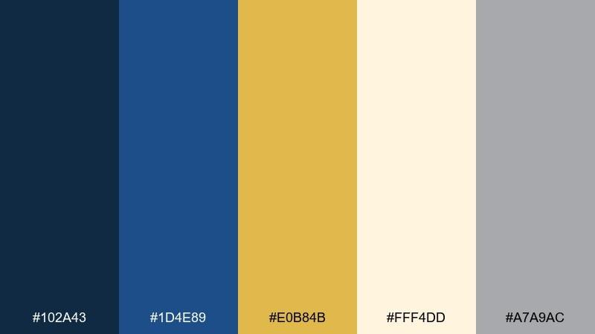



LANDING PAGE

INVOICE/RECEIPT
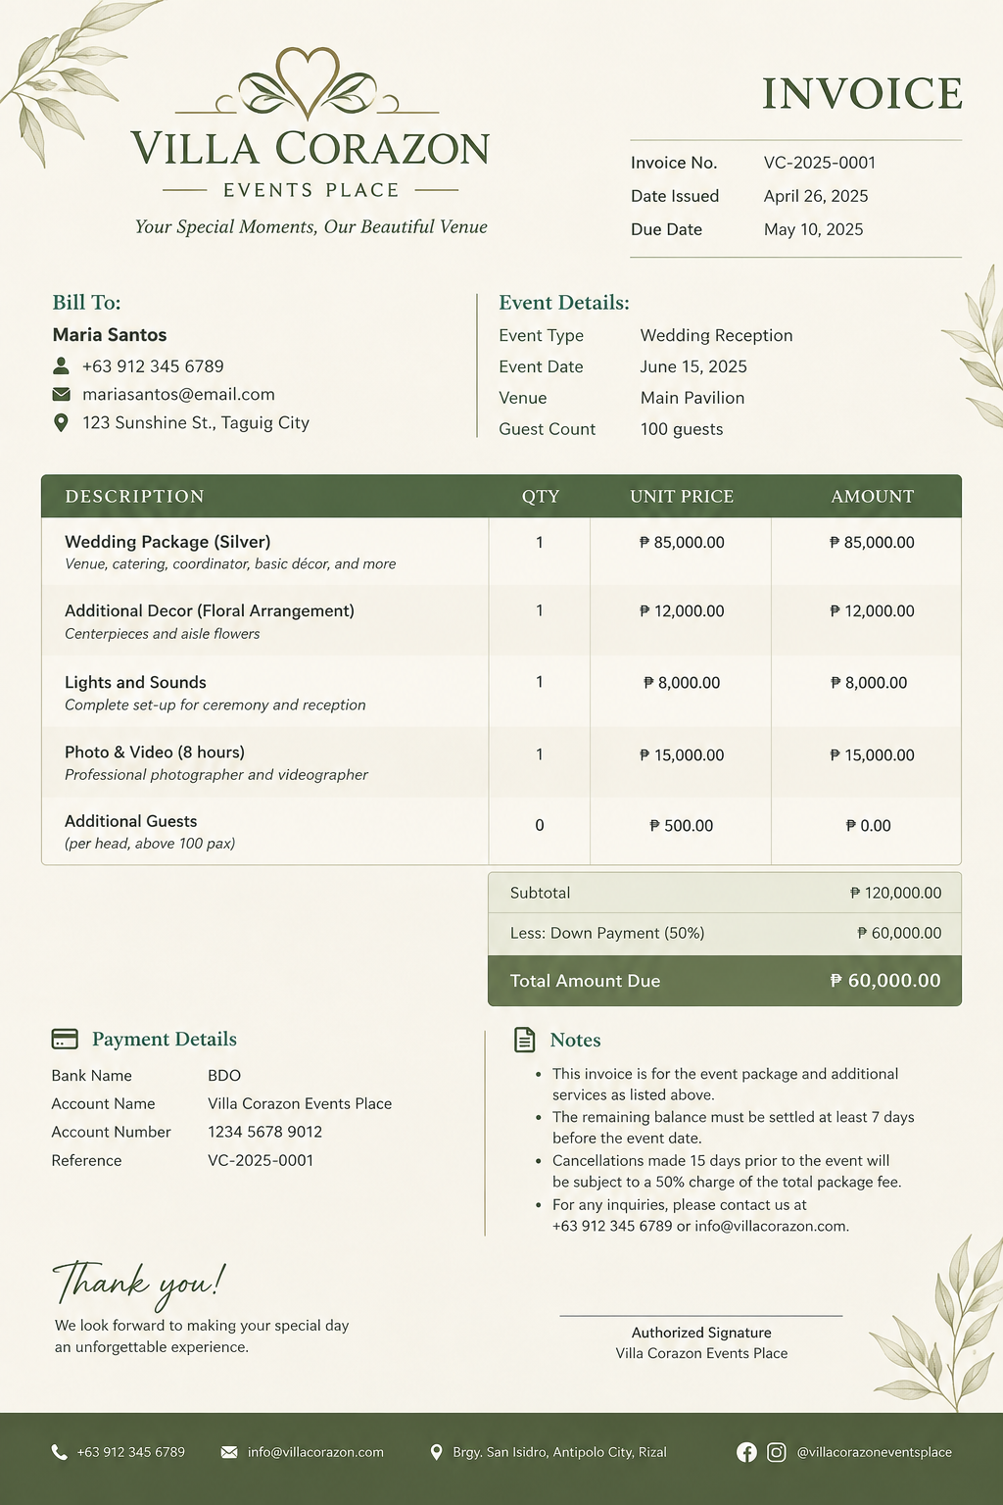
Involves:

- Title
- Metadata
- Address
- Event Details
- Content
  - Description(Package
  - Quantity
  - Unit Price
  - Full Amount
- Total
- Payment Details
- Notes
- Thank you
- Signature
- Background Design/Theme


UNIVERSITY OF RIZAL SYSTEM
Province of Rizal
College of Science

A PROPOSED MANAGEMENT AND RESERVATION SYSTEM FOR VILLA CORAZON EVENTS PLACE
In Partial Fulfillment of the Requirements in Systems Analysis and Design

Members:
John Karl M. Anore Rowena Jhen T. Albis John Wayne Andrei P. Asi
Juztine Coltrane V. Bernardo
Domm Simri R. Buenviaje
Prince Charles B. Calinog
Zaira Mae G. Catanan

BS IN COMPUTER SCIENCE

MARIA CECILIA P. SAN JOSE
Professor

November 2026
TABLE OF CONTENTS

I. HISTORICAL BACKGROUND OF THE ORGANIZATION 3
II. BRIEF DESCRIPTION OF THE SYSTEM 3
III. THE EXISTING SYSTEM 4
1. Description of the Existing System 4
2. Data Flow Diagram 5
a. Context Level DFD 5
Figure 1. Context Level DFD 5
b. Level 1 DFD 6
Figure 2. Level 1 DFD 6
c. Level 2 DFD 6
3. Existing Data Dictionary 6
IV. PROBLEM DEFINITION 6
V. OBJECTIVES 6
1. General Objective 7
2. Specific Objectives 7
VI. THE PROPOSED SYSTEM 7
1. Description of Proposed System 7
2. Conceptual Model for the Proposed System 7
3. Data Flow Diagram 7
a. Context Level DFD 7
b. Level 1 7
c. Level 2 7
4. Data Dictionary 7
5. Proposed Hardware and Software Specification 7
a. Hardware 7
b. Software 7
c. Costs 7
c.1. Recursive Costs 8
c.2. Non-Recursive Costs 8
APPENDICES 8
A. SAMPLE USER INTERFACE OF THE PROPOSED SYSTEM 8
B. GANTT CHART OF ACTIVITIES 8
C. OTHER RELEVANT DOCUMENTS 8
C. CURRICULUM VITAE 8

HISTORICAL BACKGROUND OF THE ORGANIZATION

Villa Corazon Events Place was established in mid-2026 by its owners, Gildo and Jennelyn Gutierrez, whose dream of creating a venue for family gatherings began in 1995. The idea originated from her family's tradition of celebrating special occasions and gathering together for parties. However, due to the limited space available for these gatherings, she dreamed of having a larger venue where relatives could come together and create memorable experiences. Initially, this dream seemed difficult to achieve because they lacked financial resources at the time.

In 2019, the opportunity to pursue this long-held dream emerged when a land owner offered a property. After securing employment and gaining the opportunity to make the vision possible, Jenn Gutierrez decided to pursue the project. Construction of Villa Corazon began in the same year but was temporarily halted due to the COVID-19 pandemic. When circumstances returned to normal in 2022, construction resumed until it was finished in 2025.

Villa Corazon Events Place mainly focused on providing a venue for small gatherings and celebrations. During its early years, the available space could accommodate only around 50 guests. This limitation affected the venue's ability to attract customers, as many prospective clients typically inquired about spaces that could accommodate 100 guests or more. Consequently, the limited capacity became a challenge in attracting inquiries and meeting the needs of potential customers.

To address this limitation, the development of Villa Corazon was carried out in stages. The first stage involved constructing an annex building, referred to as the guest house, which provided accommodation for guests. This was followed by the construction of the main building, which serves as the principal event venue. The completion of the main building marked a significant milestone in the development of the establishment, allowing it to expand its capacity and accommodate larger gatherings.

Since the completion of its facilities, Villa Corazon Events Place has increased its capacity from approximately 50 guests to 150 guests, with the possibility of accommodating up to 200 guests. At present, its primary service is providing an event venue for individuals and groups seeking a space for gatherings and celebrations. Through the gradual development of its facilities, Villa Corazon has progressed from a long-standing dream into an established event venue designed to accommodate larger groups and provide a space for memorable occasions.

BRIEF DESCRIPTION OF THE SYSTEM
The system being studied is the existing management and reservation process of Villa Corazon Events Place. The establishment currently handles reservation information through a manual logbook and communicates with customers through walk-in inquiries and online messaging platforms, including Facebook Messenger.
Customers who visit the venue may inquire about the facilities, available dates, and rental rates. Those who inquire online may request venue photographs, pricing information, and schedule availability. Management asks customers for relevant event details, including the type of event, preferred date and time, and estimated number of guests. After reviewing the customer's requirements and checking the logbook whether the requested date is available, the management provides a quotation. If the customer agrees to the quotation, a reservation deposit is required before the date is recorded as reserved.

The establishment offers day, night, and whole-day venue rental options. Its facilities include the Grand Hall, Alfresco, Veranda, Guest Room, and Guest House. The Grand Hall can accommodate approximately 100 to 150 guests, the Alfresco around 50 guests, and the veranda around 40 guests, according to the interview. The owners also indicated that customers may request flexible arrangements involving the venue's separate spaces. Tables and chairs are not currently included in the venue-only offering, while contacts for catering and lights-and-sound services may be referred to customers.

The current system requires management to answer inquiries, communicate with customers, check the logbook, prepare quotations, and record a reservation after receiving the deposit. Cancellations and rescheduling are also handled manually by checking the logbook and coordinating the requested changes with the customer. The owner identified the reservation date and time as the most important information to monitor to avoid double-bookings and scheduling conflicts.
Payment handling is another area that requires improvement. The owner stated that a deposit is required to reserve a date, that the deposit is non-refundable, and that the remaining balance is payable on or before the event. The owner also expressed interest in a report showing the customer or guest, deposit received, payment status, event date, and whether the balance has been paid. A more systematic way of recording and monitoring payments is therefore a relevant requirement for the proposed system.

The proposed online management and reservation system will be designed to address these operational needs. The customer-facing website will display venue photographs, facility descriptions, capacities, rental options, package information, relevant policies, and contact details. Its design will follow the owner's preference for a luxurious yet affordable appearance, using navy blue as the primary color and creating a welcoming impression that reflects the meaning of “Corazon,” or heart.

The proposed system will also provide a secured management dashboard for maintaining customer information, checking and managing venue availability, recording reservations, managing venue details and rental rates, and tracking deposits and outstanding balances. It may generate invoices or receipts, record reservation changes, and provide reports for upcoming events, booking schedules, and payment statuses. These functions will be implemented according to the requirements confirmed by the owners.

The system is intended to improve the organization and accessibility of reservation information, reduce reliance on a handwritten logbook, and help management monitor dates and payments more efficiently. It will also allow prospective customers to obtain essential venue information without having to visit the establishment simply to ask about its facilities, rates, or availability.

THE EXISTING SYSTEM

Description of the Existing System
The system being studied is the Management and Reservation System of Villa Corazon Events Place. The existing process involves the handling of clients, event reservations, venue availability, event packages, additional services, payments, and communication between the establishment and its clients.

At present, the reservation/management process currently uses a manual management and reservation process. The establishment records customer and reservation information in a pen-and-paper logbook. Customers can inquire through walk-ins or by contacting management through Facebook Messenger and other online messaging platforms. The process depends on communication between customers and management, manual checking of the logbook, preparation of quotations, and recording of reservations after payment of the required deposit.

Additionally, Management uses a logbook to manually determine reservations, cancellations, and payment. The owner emphasized that the date and timing of reservations are especially important because overlapping bookings can result in double-bookings or scheduling conflicts. Since availability is checked manually, management must consult the recorded reservations when responding to inquiries and processing schedule changes.

Although the current process allows Villa Corazon Events Place to accommodate customer inquiries and reservations, the lack of a centralized computerized system may increase the risk of scheduling conflicts and difficulties in retrieving records. These limitations provide a basis for proposing a Management and Reservation System that can improve recordkeeping, monitor venue availability, and organize reservation and payment information more efficiently.

Data Flow Diagram

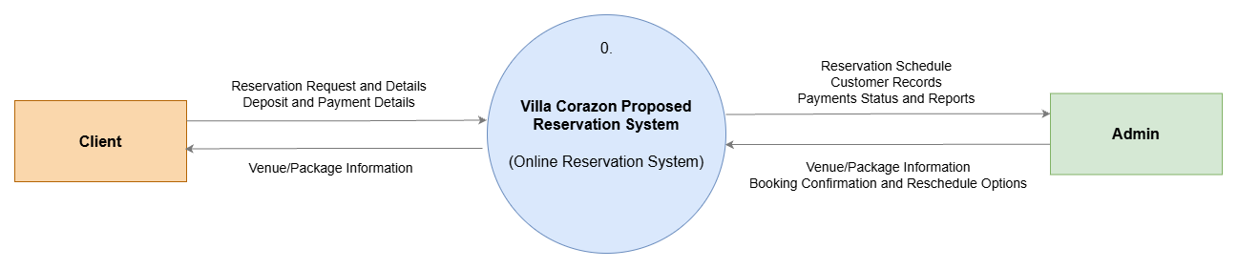
Context Level DFD

Figure 1. Context Level DFD

Level 1 DFD

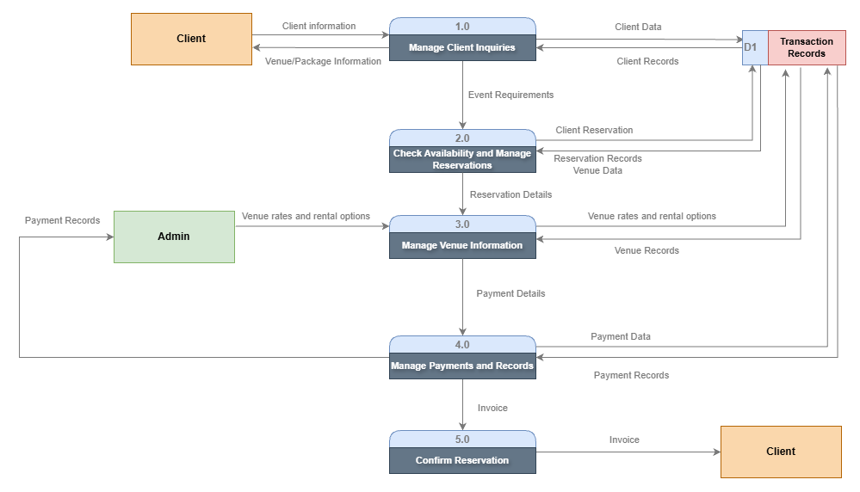Figure 2. Level 1 DFD

Level 2 DFD

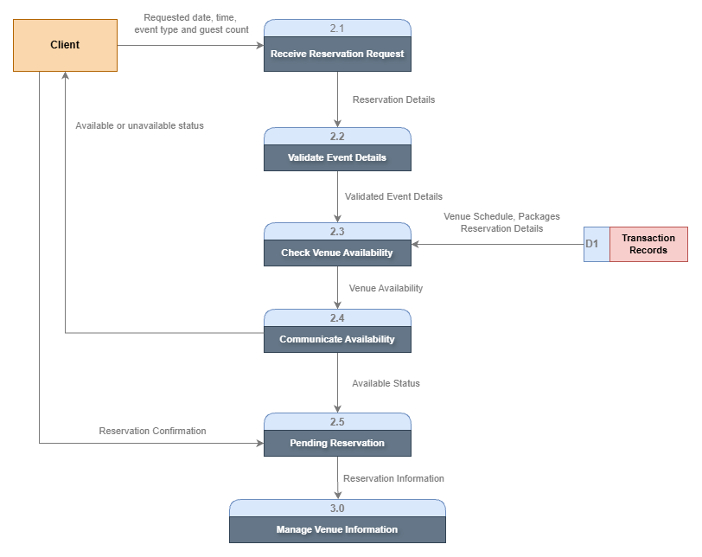Figure 3. Level 2 DFD 2.0

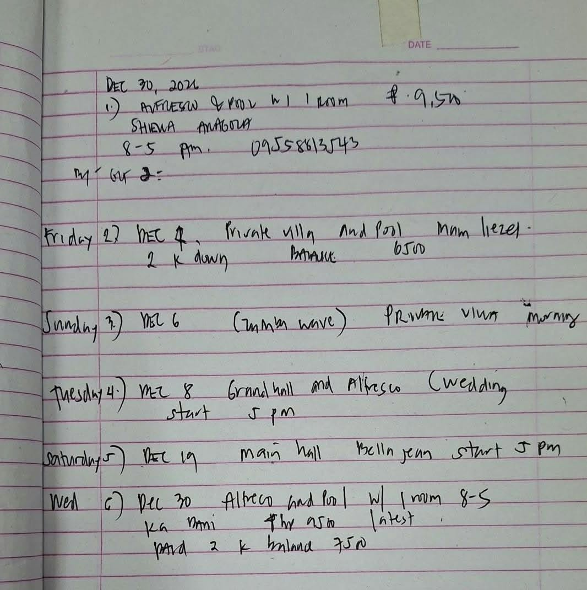
Existing Data Dictionary

DD1

Customer Reservation Form = Event Date + Start Time + Venue Name + Customer Name + Guest Count + Payment(Partial/Full) + Contact Number

Field Name | Data Type | Data Format | Size | Description | Example
Event Date | Date | YYYY-MM-DD | 10 | The scheduled date of the event. | 2026-11-15
Start Time | Time | HH:MM AM/PM | 8 | The time the event begins. | 02:00 PM
End Time | Time | HH:MM AM/PM | 8 | The time the event ends | 10:00 PM
Venue Name | Text |  | 50 | The name of the venue reserved for the event. | Grand Hall & Alfresco
Customer Name | Text |  | 40 | The full name of the customer making the reservation. | Juan Dela Cruz
Guest Count | Numeric | NN | 4 | The total number of guests expected to attend the event. | 25
Payment(Partial/Full) | Text |  | 20 | Indicates whether the payment is partial or full. | Full
Payment Price | Numeric |  | 20 | The amount paid by the customers for the reservation | ₱9,500.00
Contact Number | Text | 09NN-NNN-NNN | 11 | The customer's contact number for reservation updates and inquiries. | 0912-847-2874

PROBLEM DEFINITION
Villa Cora Zon Events Place currently manages customer information, reservations, and event schedules using a manual process with a logbook. Customers can inquire and make reservations through walk-ins or online communication platforms. The staff handles customer inquiries, checks available dates, provides quotations, and confirms reservations after receiving the required deposit. The current process has several limitations that affect the management of reservations and customer inquiries.
Problem 1: Manual Reservation and Schedule Management
The staff manually checks the logbook to determine the availability of requested event dates. The same process is followed when handling cancellations and rescheduling requests. This requires time and careful verification to maintain accurate booking records and minimize the risk of scheduling conflicts and double bookings.
Problem 2: Limited Access to Reservation Information
Customers who inquire through online platforms must communicate with the staff to obtain information about venue availability, facilities, and rental rates. The limited accessibility of this information may cause delays in the reservation process and may lead potential customers to consider other venues when their inquiries cannot be addressed promptly.
Problem 3: Time-Consuming Customer Inquiries
The staff needs to respond to customer questions about venue availability, capacity, location, pictures, and prices. They also need to gather event details and prepare quotations before a reservation can be confirmed. Handling these inquiries manually requires time and personal interaction between the staff and customers.
Problem 4: Lack of a Centralized Reservation and Payment Monitoring System
Villa Cora Zon Events Place currently relies on manual records to manage reservations and monitor payments. Details such as reserved event dates, deposits received, payment status, and outstanding balances must be recorded and checked manually. The absence of a computerized system may make it more difficult to maintain organized records and monitor transactions efficiently as the number of reservations increases.

OBJECTIVES

General Objective
To design, develop, and implement a Villa Cora Zon Venue Reservation and Management System that automates reservation processing, streamlines administrative tasks, simplifies payment tracking and package management, and provides customers with a fully accessible online platform to check real-time availability, view venue details, take virtual tours, and complete bookings instantly — replacing the current pen-and-paper logbook system, eliminating dependency on staff availability for inquiries, and capturing opportunities that would otherwise be lost due to limited accessibility.

2. Specific Objectives

Specifically, this project aims to achieve the following:

- To analyze the existing manual process of Villa Cora Zon - including logbook-based reservation recording, in-person inquiry handling, and manual management cancellations, rescheduling, and payments — and identify core problems such as the need for a staff member to be present to answer queries, risk of double-booking or record loss, delayed responses to remote clients, and lost business opportunities when instant booking is unavailable.
- To design a centralized, secure database that stores venue details, day/night/whole-day event packages, guesthouse accommodation information, client records, reservation status, payment history, quotations, and partner service listings (lights-and-sound, catering) to ensure data consistency, easy retrieval, and organized record-keeping.
- To develop a customer-facing platform that displays venue photos, capacity details, location, and package information; provides a virtual tour; shows real-time date availability; allows users to customize packages and request quotations for additional services; and enables direct reservation submission and down payment processing — so clients can book independently, anytime, from anywhere.
- To build an administrative module that automates schedule monitoring, flags date conflicts to prevent double-booking, tracks reservations, cancellations, rescheduling, and payment statuses; generates quotations and transaction records; and provides management with the reports and dashboards currently lacking — drastically reducing manual writing and logbook dependency.
- To design the system interface using navy blue as the primary color, reflecting classiness, elegance, and luxury while conveying affordability, warmth, and a welcoming home-like atmosphere; presenting an immediate impression of happiness and quality service upon access.

THE PROPOSED SYSTEM

Description of Proposed System

Conceptual Model for the Proposed System

Data Flow Diagram

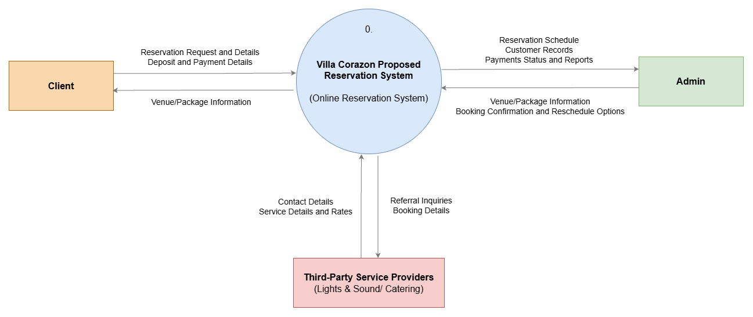
Context Level DFD

Figure 4. Context Level DFD

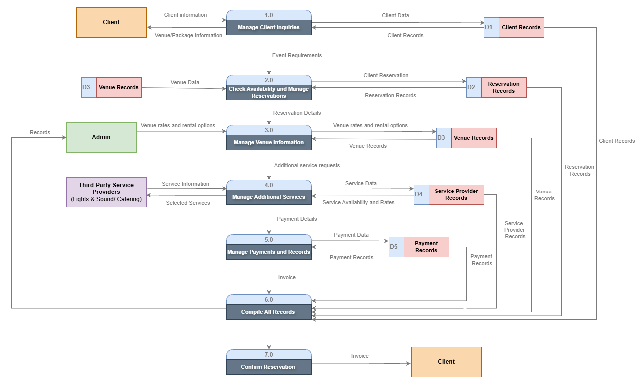
Level 1

Figure 5. Lvl 1 DFD

Level 2

Data Dictionary
This data dictionary contains information about the data that will be collected, processed, and controlled by the Villa Corazon Events Place Management System to be used. Given the fact that the business is currently using the manual log book process and pen and paper procedure, the system will collect data electronically.

- Customer Table

Field Name | Data Type | Description
CustomerID | INT (PK) | Unique identification number of the customer
CustomerName | VARCHAR(100) | Full name of the customer
ContactNumber | VARCHAR(20) | Customer's mobile or telephone number
Email | VARCHAR(100) | Customer's email address
Address | VARCHAR(255) | Customer’s address

- Reservation Table

Field Name | Data Type | Description
ReservationID | INT(PK) | Unique identification number of the reservation
CustomerID | INT(FK) | Identifies the customer who made the reservation
VenueID | INT(FK | Identifies the venue being reserved
EventType | VARCHAR(100) | Type of event, such as wedding, birthday, or gathering
EventDate | DATE | Scheduled date of the event
StartTime | TIME | Starting time of the event
EndTime | TIME | Ending time of the event
GuestCount | INT | Number of expected guests
ReservationDate | DATE | Date when the reservation was created
ReservationStatus | VARCHAR(30) | Status of the reservation, such as Pending, Confirmed, or Cancelled
TotalAmount | DECIMAL(10,2) | Total agreed reservation cost
SpecialRequest | TEXT | Additional requests from the customer

- Venue Table

Field Name | Data Type | Description
VenueID | INT(PK) | Unique identification number of the venue
VenueName | VARCHAR(100) | Name of the venue, such as Grand Hall, Alfresco, or Veranda
Capacity | INT | Maximum number of guests the venue can accommodate
VenueDescription | TEXT | Description of the venue and its features
VenueRate | DECIMAL(10,2) | Rental price of the venue
AvailabilityStatus | VARCHAR(30) | Indicates whether the venue is available or unavailable
VenueImage | VARCHAR(255) | File path or URL of the venue image

- Payment Table

Field Name | Data Type | Description
PaymentID | INT(PK) | Unique identification number of the payment
ReservationID | INT(FK) | Identifies the reservation associated with the payment
PaymentDate | DATE | Date when the payment was received
PaymentAmount | DECIMAL(10,2) | Amount paid by the customer
PaymentType | VARCHAR(30) | Type of payment, such as Deposit or Balance
PaymentMethod | VARCHAR(50) | Method used to pay, such as Cash or Online Payment
PaymentStatus | VARCHAR(30) | Status of payment, such as Pending, Paid, or Partially Paid
ReferenceNumber | VARCHAR(100) | Transaction reference number, if applicable
RecordedBy | INT (FK) | Identifies the admin who recorded the payment

- Package Table

Field Name | Data Type | Description
PackageID | INT(PK) | Unique identification number of the package
PackageName | VARCHAR(100) | Name of the rental package
PackageDescription | TEXT | Details and inclusions of the package
PackageType | VARCHAR(30) | Type of rental, such as Day, Night, or Whole Day
PackagePrice | DECIMAL(10,2) | Price of the package
PackageStatus | VARCHAR(30) | Indicates whether the package is available

Note: According to the interview, the current offering is primarily venue rental. Tables, chairs, and other services should not be listed as included in a package unless the owner confirms them.

- Reservation Package Table
This table connects reservations to packages and allows a reservation to include multiple packages or additional venue options when permitted.

Field Name | Data Type | Description
ReservationPackageID | INT (PK) | Unique identification number for the reservation-package record
ReservationID | INT (FK) | Identifies the reservation
PackageID | INT (FK) | Identifies the selected package
Quantity | INT | Number of units or package selections
Subtotal | DECIMAL(10,2) | Total cost for the selected package

- Admin Table

Field Name | Data Type | Description
AdminID | INT(PK) | Unique identification number of the administrator
AdminName | VARCHAR(100) | Full name of the administrator
Username | VARCHAR(50) | Login username
PasswordHash | VARCHAR(255) | Securely stored password hash
Email | VARCHAR(100) | Administrator's email address
AdminRole | VARCHAR(50) | Role or access level of the administrator

- Service Provider Table

Based on the interview, Villa Corazon currently has contacts for lighting and sound services and catering services.

Field Name | Data Type | Description
ProviderID | INT (PK) | Unique identification number of the service provider
ProviderName | VARCHAR(100) | Name of the service provider or business
ServiceType | VARCHAR(50) | Type of service, such as Catering or Lights and Sounds
ContactNumber | VARCHAR(20) | Service provider's contact number
Email | VARCHAR(100) | Service provider's email address
ProviderStatus | VARCHAR(30) | Indicates whether the provider is active

- Reservation Service Table
This table records additional services requested by customers and helps the admin manage optional arrangements.
Field Name | Data Type | Description
ReservationServiceID | INT (PK) | Unique identification number of the service record
ReservationID | INT (FK) | Identifies the reservation
ProviderID | INT (FK) | Identifies the selected service provider
ServiceDescription | TEXT | Details of the requested service
ServiceCost | DECIMAL(10,2) | Cost of the additional service
ServiceStatus | VARCHAR(30) | Status of the service request

- Notification Table
Based on the owner's request, the system should remind customers about their upcoming events to maintain their excitement and prevent them from forgetting their reservations.
Field Name | Data Type | Description
NotificationID | INT(PK) | Unique identification number of the notification
ReservationID | INT(FK) | Identifies the related reservation
CustomerID | INT(FK) | Identifies the recipient
NotificationMessage | TEXT | Content of the notification
NotificationType | VARCHAR(50) | Type of reminder, such as Upcoming Event or Payment Reminder
ScheduledDateTime | DATETIME | Date and time when the notification should be sent
SentStatus | VARCHAR(30) | Indicates whether the notification is Pending, Sent, or Failed

- Cancellation Table
This table keeps records of cancellations and their reasons for better reservation management and payment tracking.

Field Name | Data Type | Description
CancellationID | INT(PK) | Unique identification number of the cancellation
ReservationID | INT(FK) | Identifies the cancelled reservation
CancellationDate | DATE | Date when the reservation was cancelled
CancellationReason | TEXT | Reason for cancellation
DepositAmount | DECIMAL(10,2) | Deposit amount associated with the reservation
RefundStatus | VARCHAR(30) | Indicates whether a refund is Not Applicable, Pending, or Processed
ProcessedBy | INT(FK) | Identifies the admin who processed the cancellation

The interview states that deposits are non-refundable. The system should record cancellations and retain the deposit according to the owner's policy. Any exception or future refund policy should be confirmed by the owner before implementation.
Summary of Primary and Foreign Keys

Table | Primary Key | Foreign Key
Customer | CustomerID | None
Reservation | ReservationID | CustomerID, VenueID
Venue | VenueID | None
Payment | PaymentID | ReservationID, RecordedBy
Package | PackageID | None
Reservation Package | ReservationPackageID | ReservationID, PackageID
Admin | AdminID | None
Service Provider | ProviderID | None
Reservation Service | ReservationServiceID | ReservationID, ProviderID
Notification | NotificationID | ReservationID, CustomerID
Cancellation | CancellationID | ReservationID, ProcessedBy

The Data Dictionary presented herein represents a database design proposal from the interviews, rather than the documentation of an already computerized system. The most significant features include customers, scheduling of reservations, availability of venues, tracking deposits and balances, and automatic scheduling of events because they directly solve the problems that the owner currently faces.

Proposed Hardware and Software Specification

Hardware - Laptop, Printer,

Software -

Costs

Recursive Costs

Non-Recursive Costs

APPENDICES

A. SAMPLE USER INTERFACE OF THE PROPOSED SYSTEM

B. GANTT CHART OF ACTIVITIES

C. OTHER RELEVANT DOCUMENTS

C. CURRICULUM VITAE

UNIVERSITY OF RIZAL SYSTEM
Province of Rizal
College of Science

A PROPOSED MANAGEMENT AND RESERVATION SYSTEM FOR VILLA CORAZON EVENTS PLACE
In Partial Fulfillment of the Requirements in Systems Analysis and Design

Members:
John Karl M. Anore Rowena Jhen T. Albis John Wayne Andrei P. Asi
Juztine Coltrane V. Bernardo
Domm Simri R. Buenviaje
Prince Charles B. Calinog
Zaira Mae G. Catanan

BS IN COMPUTER SCIENCE

MARIA CECILIA P. SAN JOSE
Professor

November 2026
TABLE OF CONTENTS

I. HISTORICAL BACKGROUND OF THE ORGANIZATION 2
II. BRIEF DESCRIPTION OF THE SYSTEM 2
III. THE EXISTING SYSTEM 2
1. Description of the Existing System 2
2. Data Flow Diagram 2
a. Context Level DFD 2
b. Level 1 DFD 2
c. Level 2 DFD 2
3. Existing Data Dictionary 2
IV. PROBLEM DEFINITION 2
V. OBJECTIVES 3
1. General Objective 3
2. Specific Objectives 3
VI. THE PROPOSED SYSTEM 3
1. Description of Proposed System 3
2. Conceptual Model for the Proposed System 3
3. Data Flow Diagram 3
a. Context Level DFD 3
b. Level 1 3
c. Level 2 3
4. Data Dictionary 3
5. Proposed Hardware and Software Specification 3
a. Hardware 3
b. Software 3
c. Costs 3
c.1. Recursive Costs 4
c.2. Non-Recursive Costs 4
APPENDICES 4
A. SAMPLE USER INTERFACE OF THE PROPOSED SYSTEM 4
B. GANTT CHART OF ACTIVITIES 4
C. OTHER RELEVANT DOCUMENTS 4
C. CURRICULUM VITAE 4

HISTORICAL BACKGROUND OF THE ORGANIZATION

Villa Corazon Events Place was established in mid-2026 by its owners, Gildo and Jennelyn Gutierrez, whose dream of creating a venue for family gatherings began in 1995. The idea originated from her family's tradition of celebrating special occasions and gathering together for parties. However, due to the limited space available for these gatherings, she dreamed of having a larger venue where relatives could come together and create memorable experiences. Initially, this dream seemed difficult to achieve because they lacked financial resources at the time.

In 2019, the opportunity to pursue this long-held dream emerged when a land owner offered a property. After securing employment and gaining the opportunity to make the vision possible, Jenn Gutierrez decided to pursue the project. Construction of Villa Corazon began in the same year but was temporarily halted due to the COVID-19 pandemic. When circumstances returned to normal in 2022, construction resumed until it was finished in 2025.

Villa Corazon Events Place mainly focused on providing a venue for small gatherings and celebrations. During its early years, the available space could accommodate only around 50 guests. This limitation affected the venue's ability to attract customers, as many prospective clients typically inquired about spaces that could accommodate 100 guests or more. Consequently, the limited capacity became a challenge in attracting inquiries and meeting the needs of potential customers.

To address this limitation, the development of Villa Corazon was carried out in stages. The first stage involved constructing an annex building, referred to as the guest house, which provided accommodation for guests. This was followed by the construction of the main building, which serves as the principal event venue. The completion of the main building marked a significant milestone in the development of the establishment, allowing it to expand its capacity and accommodate larger gatherings.

Since the completion of its facilities, Villa Corazon Events Place has increased its capacity from approximately 50 guests to 150 guests, with the possibility of accommodating up to 200 guests. At present, its primary service is providing an event venue for individuals and groups seeking a space for gatherings and celebrations. Through the gradual development of its facilities, Villa Corazon has progressed from a long-standing dream into an established event venue designed to accommodate larger groups and provide a space for memorable occasions.

BRIEF DESCRIPTION OF THE SYSTEM
The system being studied is the existing management and reservation process of Villa Corazon Events Place. The establishment currently handles reservation information through a manual logbook and communicates with customers through walk-in inquiries and online messaging platforms, including Facebook Messenger.
Customers who visit the venue may inquire about the facilities, available dates, and rental rates. Those who inquire online may request venue photographs, pricing information, and schedule availability. Management asks customers for relevant event details, including the type of event, preferred date and time, and estimated number of guests. After reviewing the customer's requirements and checking the logbook whether the requested date is available, the management provides a quotation. If the customer agrees to the quotation, a reservation deposit is required before the date is recorded as reserved.
The establishment offers day, night, and whole-day venue rental options. Its facilities include the Grand Hall, Alfresco, Veranda, Guest Room, and Guest House. The Grand Hall can accommodate approximately 100 to 150 guests, the Alfresco around 50 guests, and the veranda around 40 guests, according to the interview. The owners also indicated that customers may request flexible arrangements involving the venue's separate spaces. Tables and chairs are not currently included in the venue-only offering, while contacts for catering and lights-and-sound services may be referred to customers.

The current system requires management to answer inquiries, communicate with customers, check the logbook, prepare quotations, and record a reservation after receiving the deposit. Cancellations and rescheduling are also handled manually by checking the logbook and coordinating the requested changes with the customer. The owner identified the reservation date and time as the most important information to monitor to avoid double-bookings and scheduling conflicts.
Payment handling is another area that requires improvement. The owner stated that a deposit is required to reserve a date, that the deposit is non-refundable, and that the remaining balance is payable on or before the event. The owner also expressed interest in a report showing the customer or guest, deposit received, payment status, event date, and whether the balance has been paid. A more systematic way of recording and monitoring payments is therefore a relevant requirement for the proposed system.

The proposed online management and reservation system will be designed to address these operational needs. The customer-facing website will display venue photographs, facility descriptions, capacities, rental options, package information, relevant policies, and contact details. Its design will follow the owner's preference for a luxurious yet affordable appearance, using navy blue as the primary color and creating a welcoming impression that reflects the meaning of “Corazon,” or heart.

The proposed system will also provide a secured management dashboard for maintaining customer information, checking and managing venue availability, recording reservations, managing venue details and rental rates, and tracking deposits and outstanding balances. It may generate invoices or receipts, record reservation changes, and provide reports for upcoming events, booking schedules, and payment statuses. These functions will be implemented according to the requirements confirmed by the owners.
The system is intended to improve the organization and accessibility of reservation information, reduce reliance on a handwritten logbook, and help management monitor dates and payments more efficiently. It will also allow prospective customers to obtain essential venue information without having to visit the establishment simply to ask about its facilities, rates, or availability.

THE EXISTING SYSTEM

Description of the Existing System
The system being studied is the Management and Reservation System of Villa Corazon Events Place. The existing process involves the handling of clients, event reservations, venue availability, event packages, additional services, payments, and communication between the establishment and its clients.

At present, the reservation/management process currently uses a manual management and reservation process. The establishment records customer and reservation information in a pen-and-paper logbook. Customers can inquire through walk-ins or by contacting management through Facebook Messenger and other online messaging platforms. The process depends on communication between customers and management, manual checking of the logbook, preparation of quotations, and recording of reservations after payment of the required deposit.

Additionally, Management uses a logbook to manually determine reservations, cancellations, and payment. The owner emphasized that the date and timing of reservations are especially important because overlapping bookings can result in double-bookings or scheduling conflicts. Since availability is checked manually, management must consult the recorded reservations when responding to inquiries and processing schedule changes.

Although the current process allows Villa Corazon Events Place to accommodate customer inquiries and reservations, the lack of a centralized computerized system may increase the risk of scheduling conflicts and difficulties in retrieving records. These limitations provide a basis for proposing a Management and Reservation System that can improve recordkeeping, monitor venue availability, and organize reservation and payment information more efficiently.

Data Flow Diagram

Context Level DFD

Figure 1. Context Level DFD

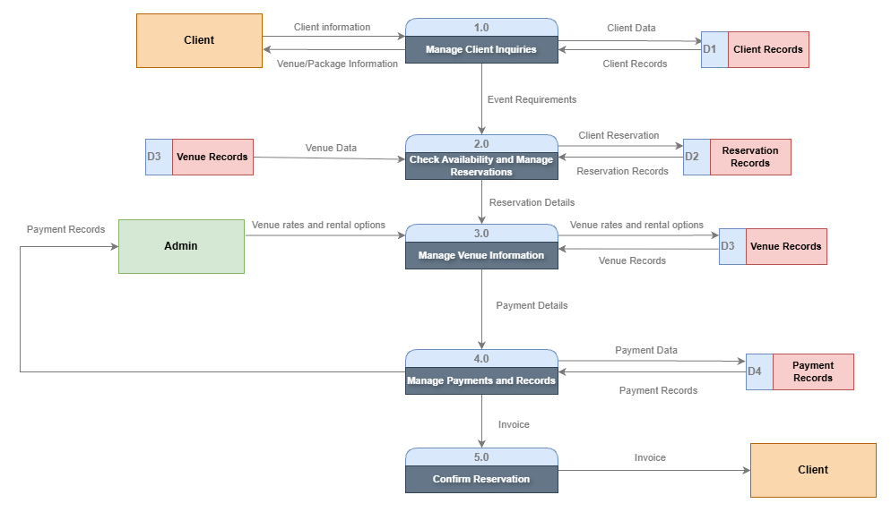
Level 1 DFD

Figure 2. Level 1 DFD

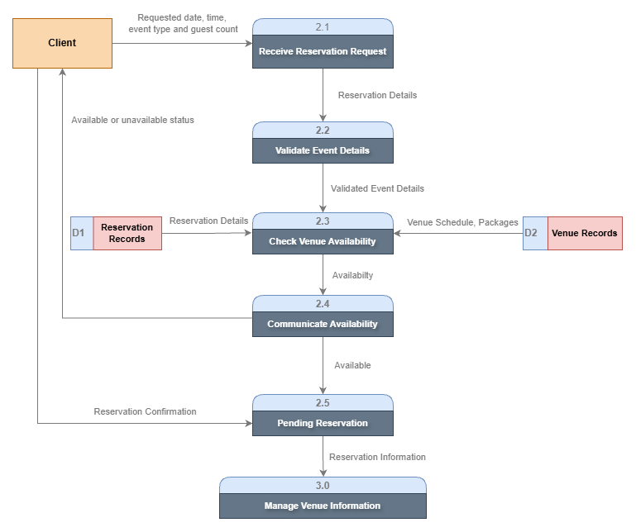
Level 2 DFD

Figure 3. Level 2 DFD 2.0

3. Existing Data Dictionary

DD1

Customer Reservation Form = Event Date + Start Time + Venue Name + Customer Name + Guest Count + Payment(Partial/Full) + Contact Number

Field Name | Data Type | Data Format | Size | Description | Example
Event Date | Date | YYYY-MM-DD | 10 | The scheduled date of the event. | 2026-11-15
Start Time | Time | HH:MM AM/PM | 8 | The time the event begins. | 02:00 PM
End Time | Time | HH:MM AM/PM | 8 | The time the event ends | 10:00 PM
Venue Name | Text |  | 50 | The name of the venue reserved for the event. | Grand Hall & Alfresco
Customer Name | Text |  | 40 | The full name of the customer making the reservation. | Juan Dela Cruz
Guest Count | Numeric | NN | 4 | The total number of guests expected to attend the event. | 25
Payment(Partial/Full) | Text |  | 20 | Indicates whether the payment is partial or full. | Full
Payment Price | Numeric |  | 20 | The amount paid by the customers for the reservation | ₱9,500.00
Contact Number | Text | 09NN-NNN-NNN | 11 | The customer's contact number for reservation updates and inquiries. | 0912-847-2874

PROBLEM DEFINITION

OBJECTIVES

General Objective

Specific Objectives

THE PROPOSED SYSTEM

Description of Proposed System

Conceptual Model for the Proposed System

Data Flow Diagram

Context Level DFD

Level 1

Level 2

Data Dictionary

Proposed Hardware and Software Specification

Hardware

Software

Costs

Recursive Costs

Non-Recursive Costs

APPENDICES

A. SAMPLE USER INTERFACE OF THE PROPOSED SYSTEM

B. GANTT CHART OF ACTIVITIES

C. OTHER RELEVANT DOCUMENTS

C. CURRICULUM VITAE

